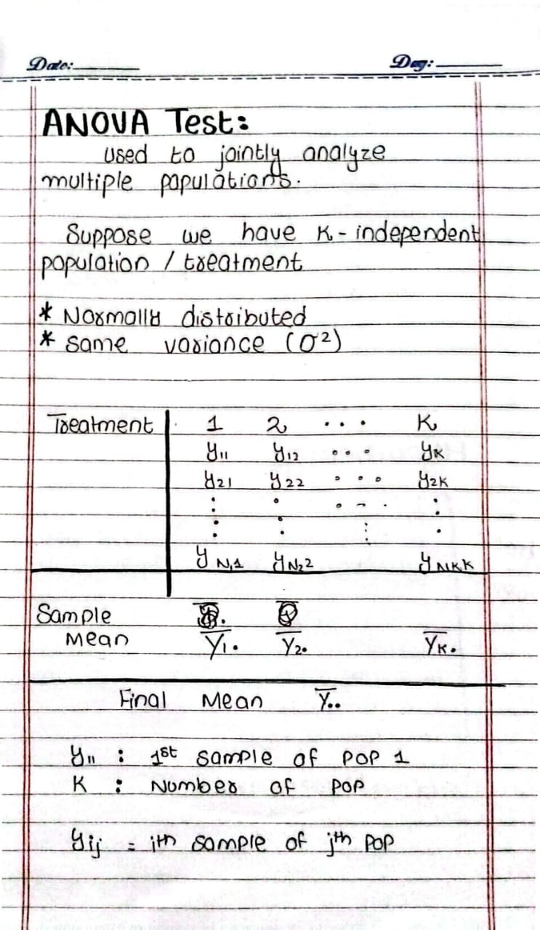
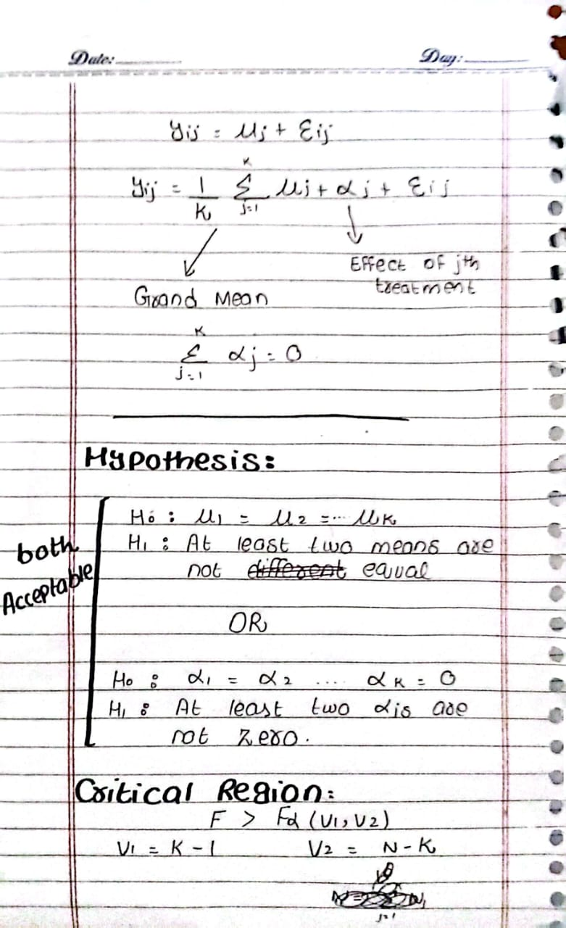
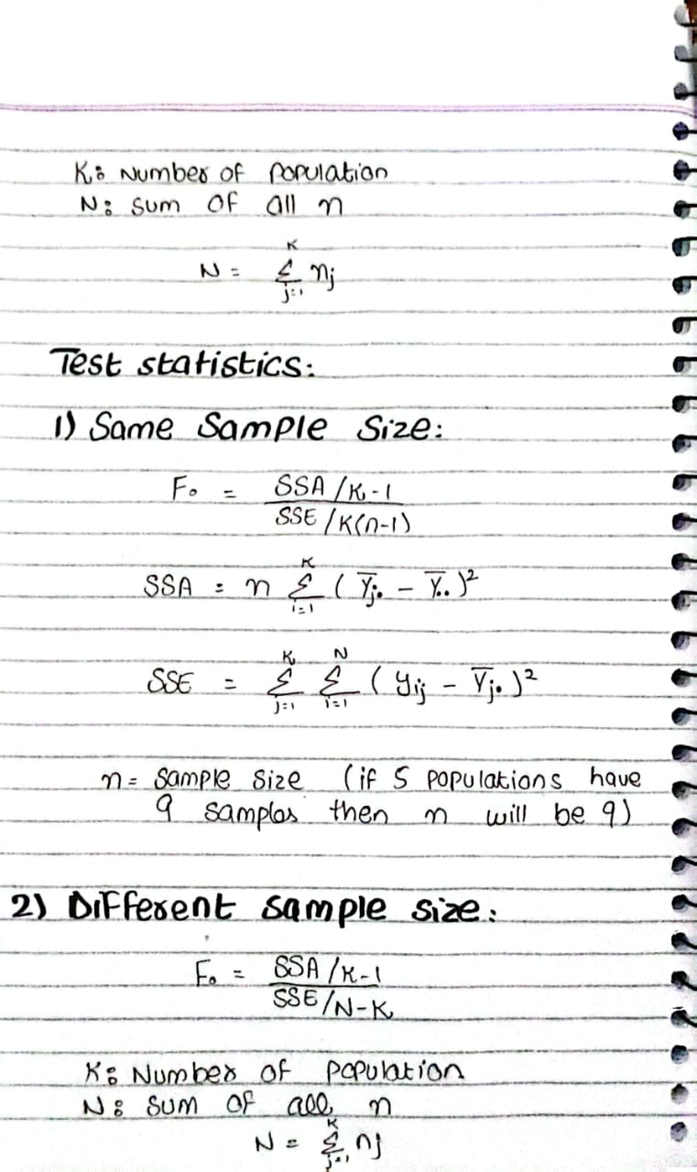
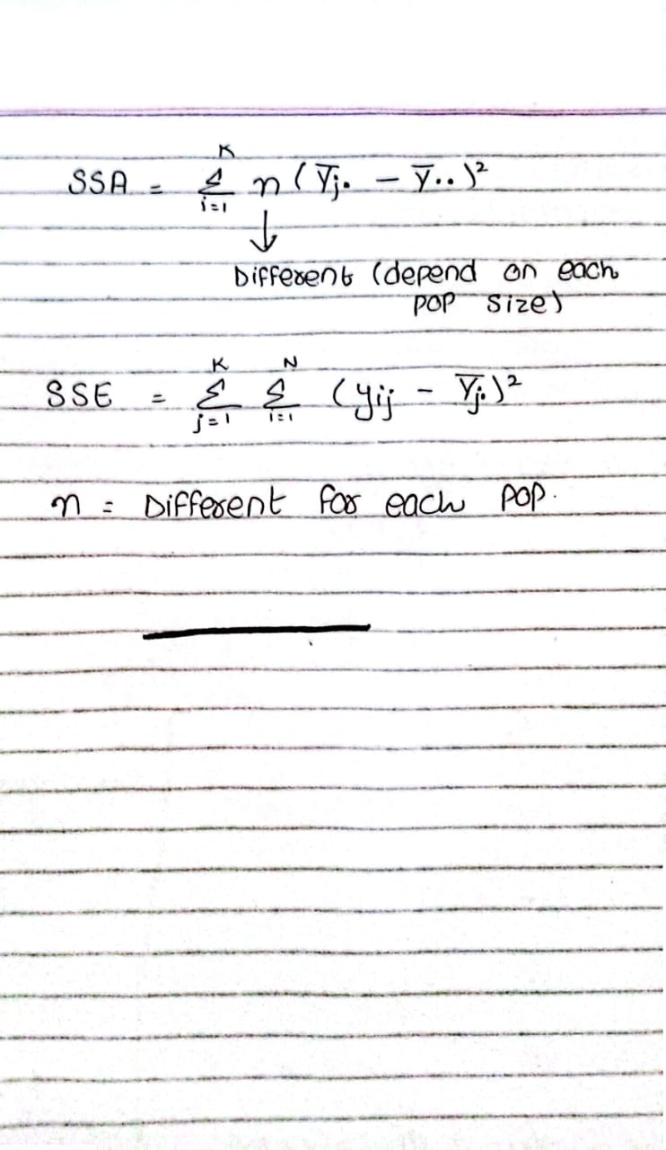
EXAMPLE 13.1
Test the hypothesis μ1 = μ2 = ···= μ5 at the 0.05 level of significance for the data of Table 13.1 on absorption of moisture by various types of cement aggregates
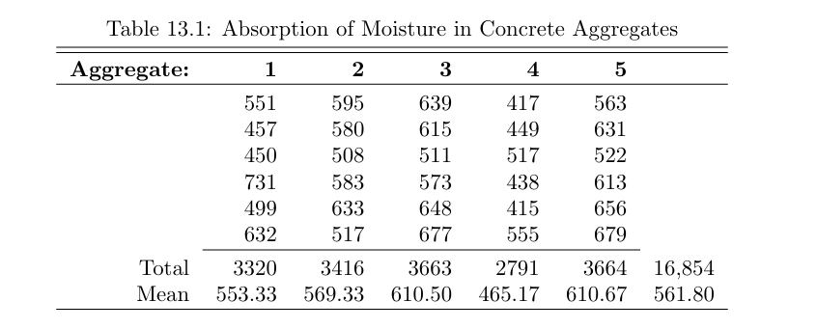
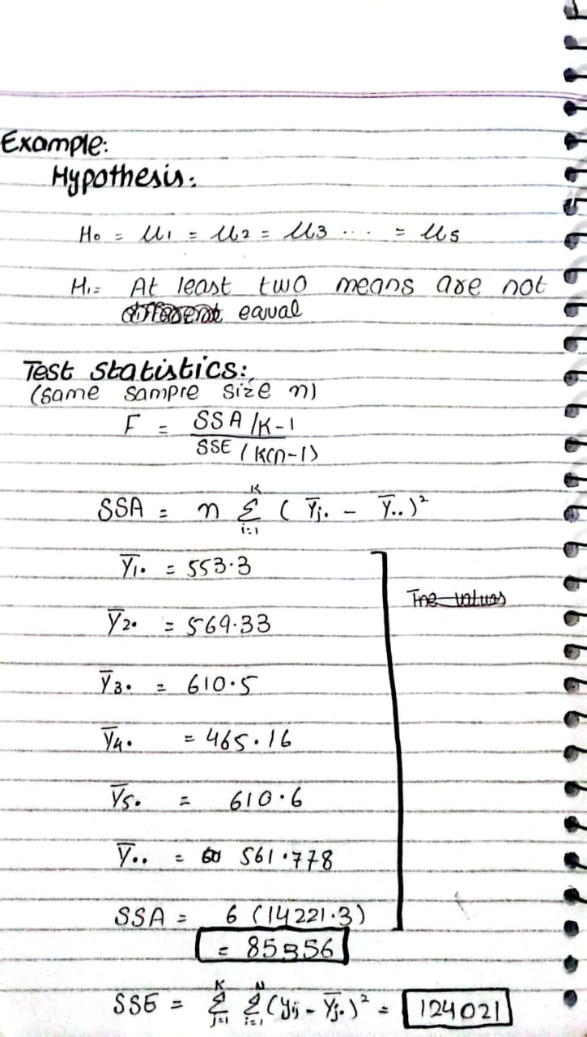
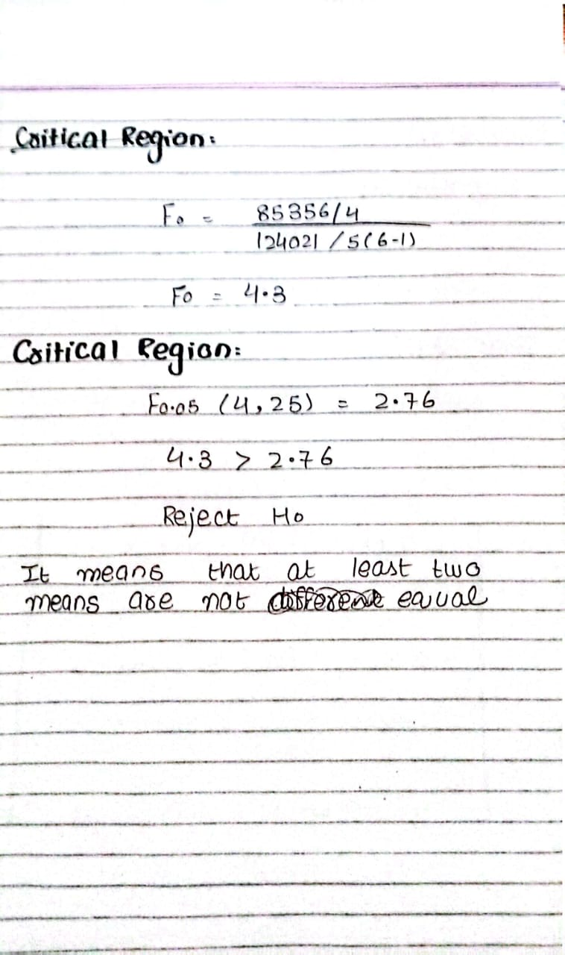

EXAMPLE 13.2:
Part of a study conducted at Virginia Tech was designed to measure serum alka line phosphatase activity levels (in Bessey-Lowry units) in children with seizure disorders who were receiving anticonvulsant therapy under the care of a private physician. Forty-five subjects were found for the study and categorized into four drug groups:
G-1: Control (not receiving anticonvulsants and having no history of seizure disorders)
G-2: Phenobarbital
G-3: Carbamazepine
G-4: Other anticonvulsants
From blood samples collected from each subject, the serum alkaline phosphatase activity level was determined and recorded as shown in Table 13.4. Test the hy pothesis at the 0.05 level of significance that the average serum alkaline phosphatase activity level is the same for the four drug groups.
